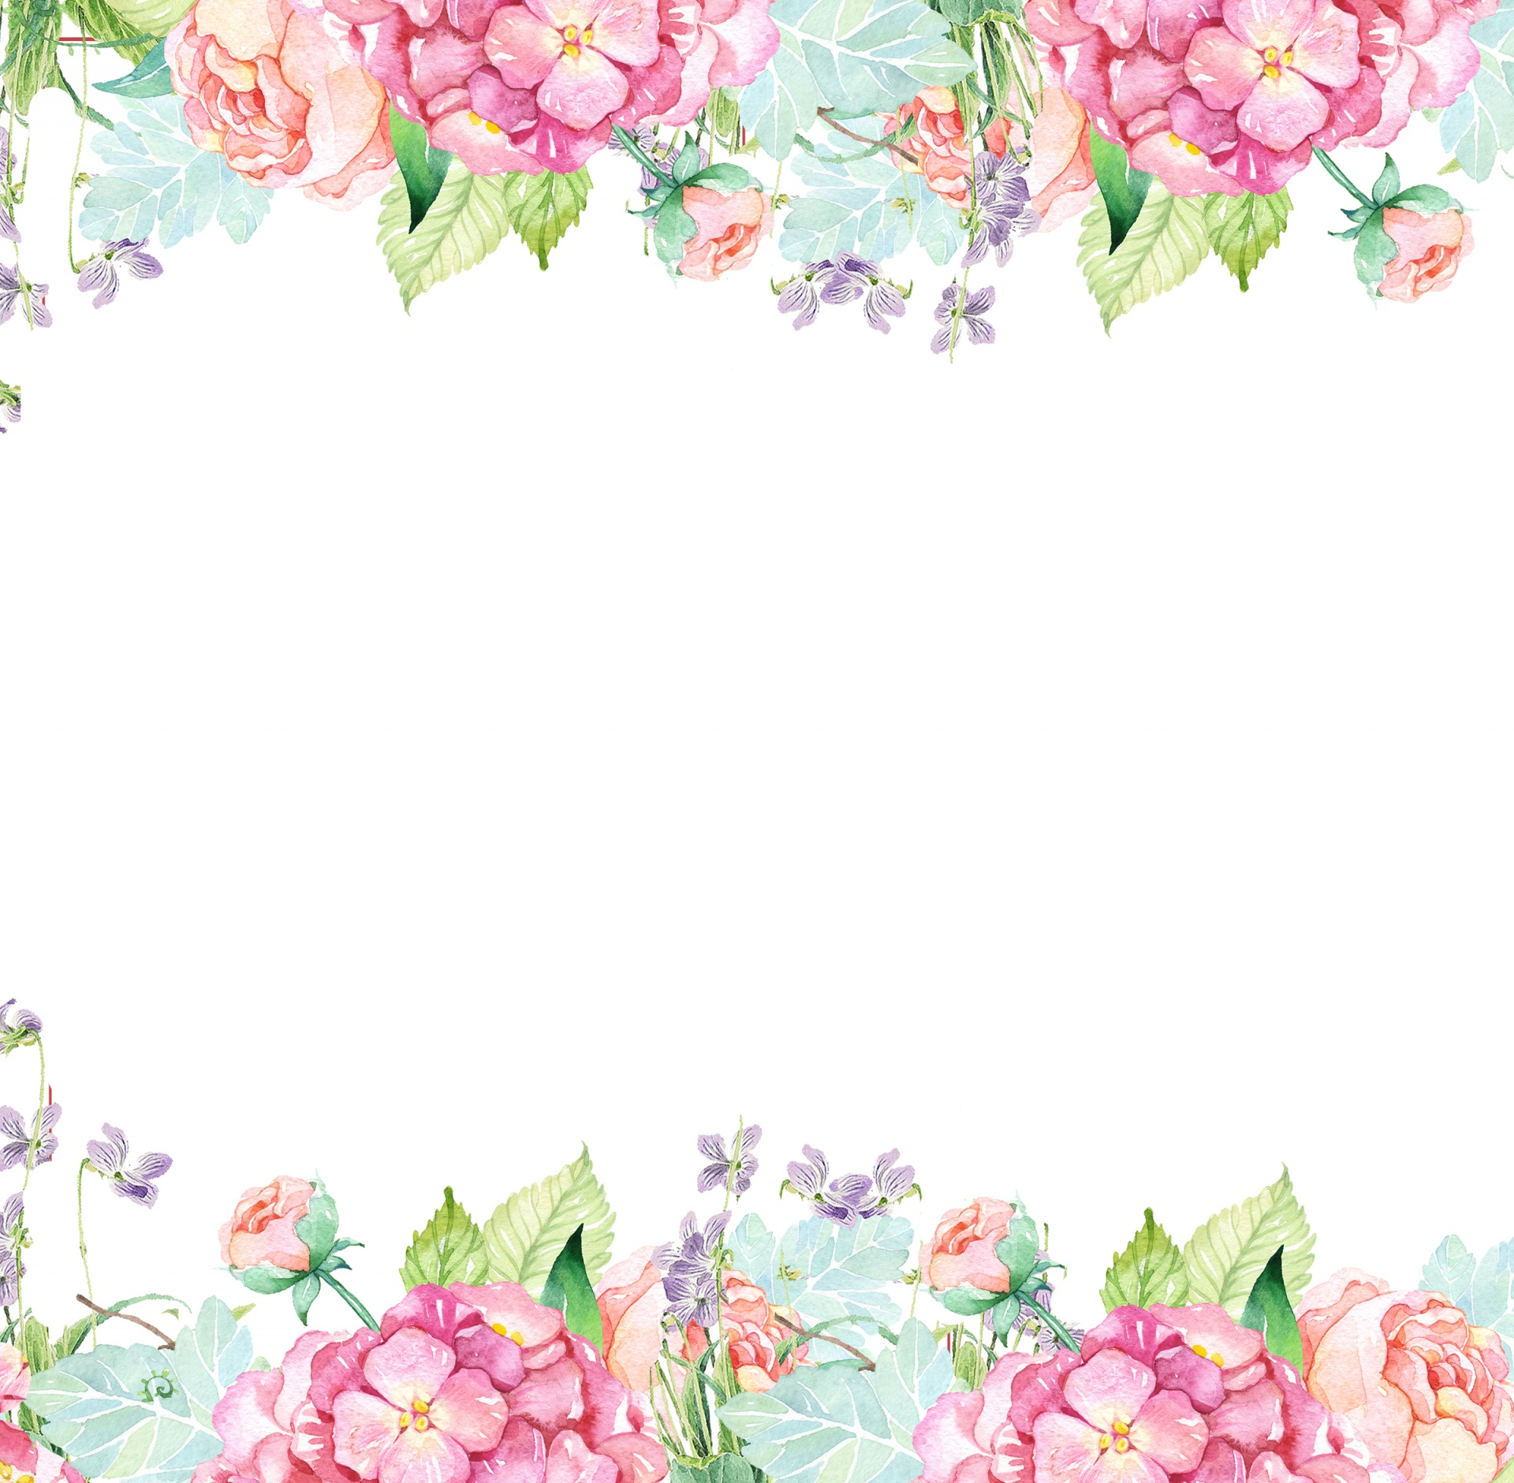

Name: Lauren Jones Initals: LBJ

Birthday: February 5

Preferred t-shirt size? Medium

What is your favorite color? Pink

What is your favorite flower/plant? Orchids and Hydrangeas

Where are your favorite places to shop? Target, Amazon, Lululemon, Homegoods

What are your favorite restaurants? Masa, Backwoods Crossing, Chick-fil-a

What do you collect (candles, foxes, etc.)? books for my classroom, volcano candles

What is your favorite cold drink? Water

What is your favorite hot drink? Black coffee or decaf tea

What is your favorite sweet treat? Anything gummy or chocolate with caramel

What is your favorite salty treat? Cashews, pretzels, pistachios

What is your favorite fruit? Granny smith apples, grapes, cantaloupe, watermelon

Do you have any food allergies? Nope!

Interests: Home renovation projects, watching baseball, and reading

UMOJA House:

Wish list for your classroom? <https://www.amazon.com/hz/wishlist/ls/3IH2HIZ82I5F6?ref_=wl_share>